How to create service principle and service connection for webapp access through ci/cd
FOR JAVA ALTERNATES USE BELOW COMMANDS:_
1.update-java-alternatives --list
2. sudo update-alternatives --config java
Deploying a Java-based Tomcat application to Azure | Azure DevOps Hands-on-Labs (azuredevopslabs.com)

(az ad sp create-for-rbac -n siri for service file creation)

- Go to Microsoft Entra ID → App registrations
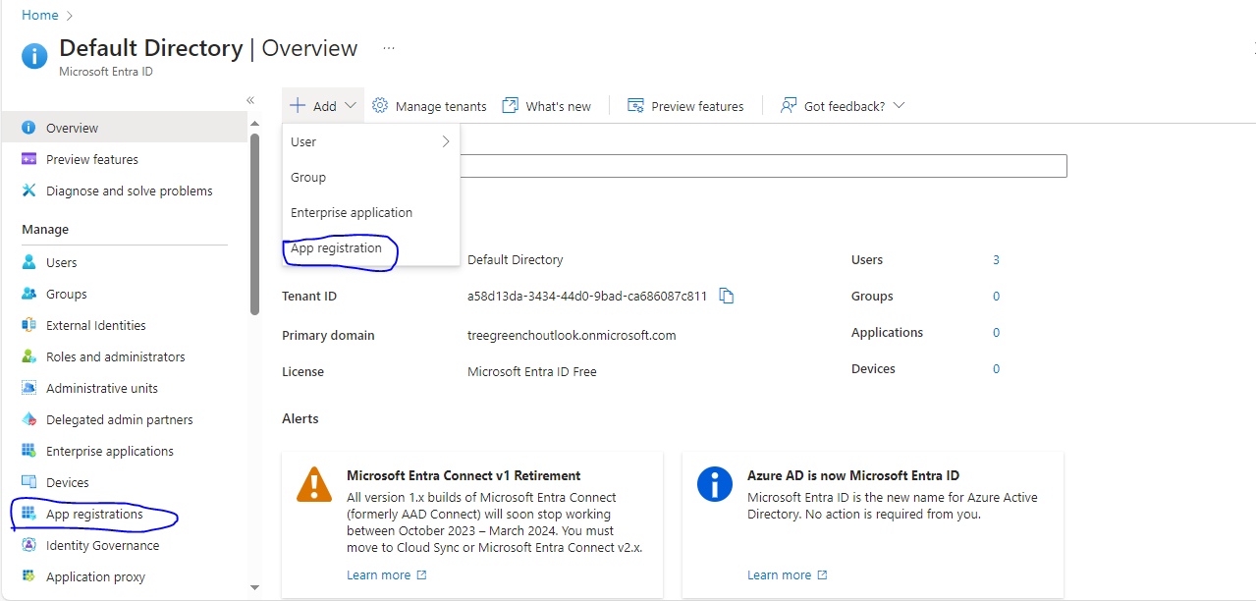
2.Register app application—name:- exp teja and select . first option
>Accounts in this organizational directory only (Default Directory only - Single tenant) (we need select this one).
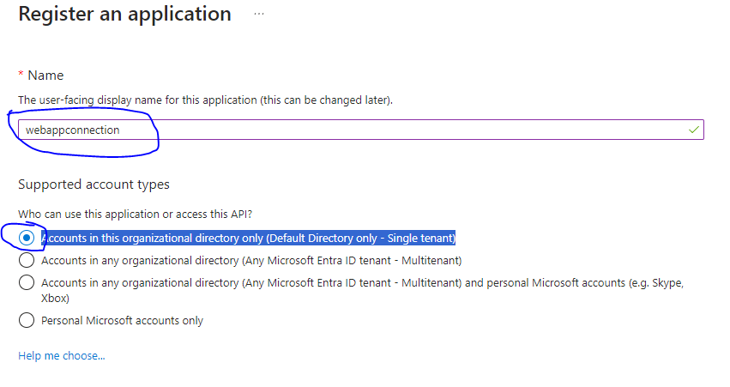
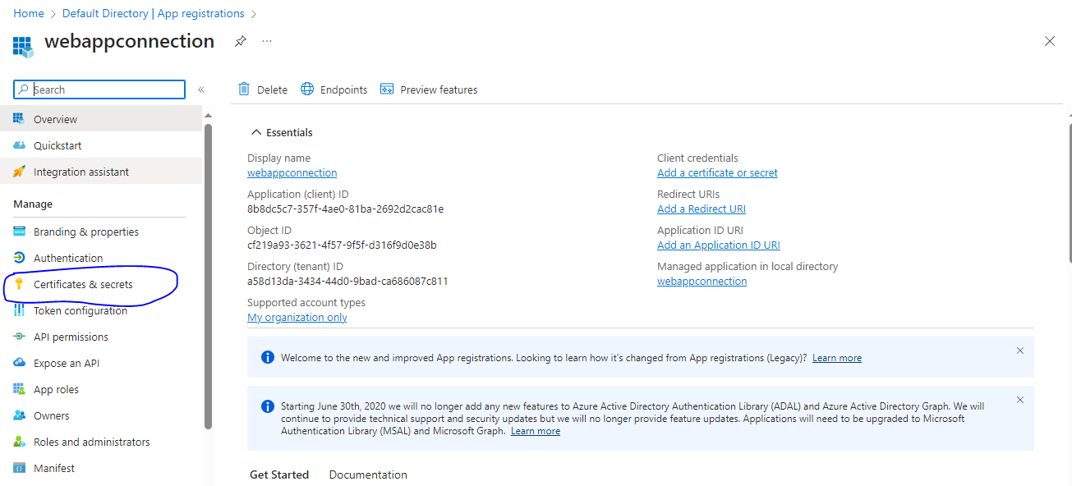
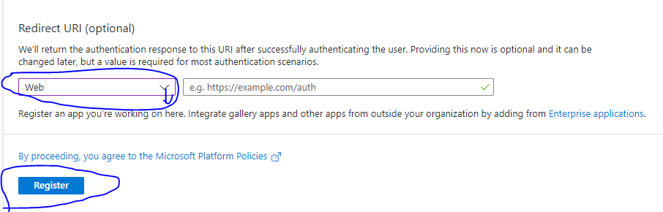

Then click register. Check the over view here showing the details. It is completed.
3.Same page navigagte to certificate and secrete. Click new client and add client name click add,
It will create value and secrete id these details note down it is enter service connection create time.

4. 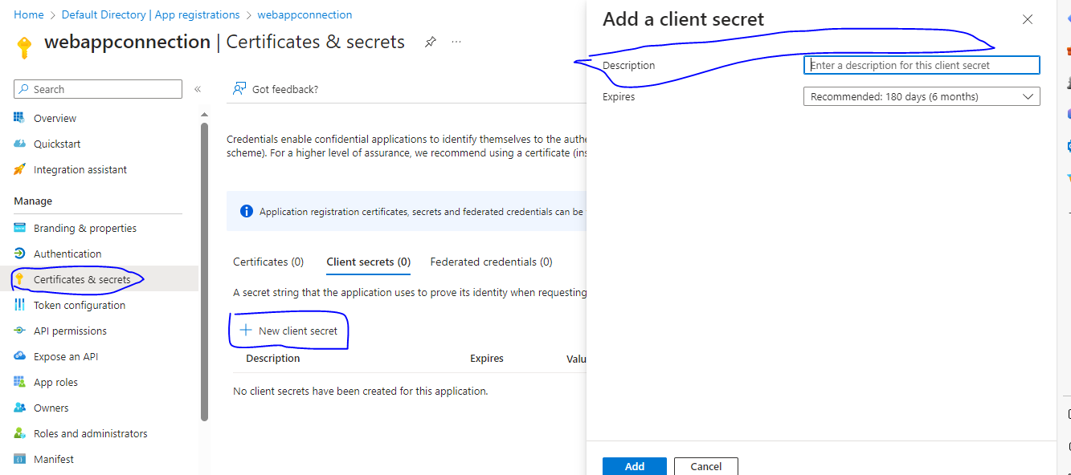

Below showing value and secrete will create these values note down it and re use to at that creation of service connection.
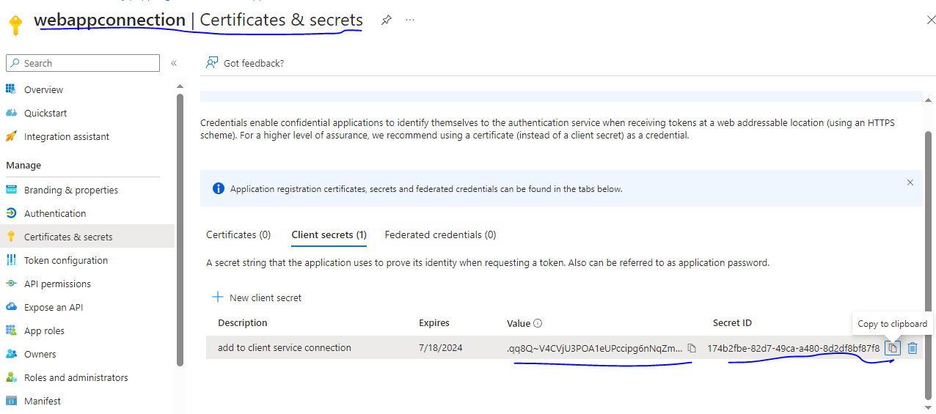

Now go to subscription→click on subscription→click on Access control (IAM),
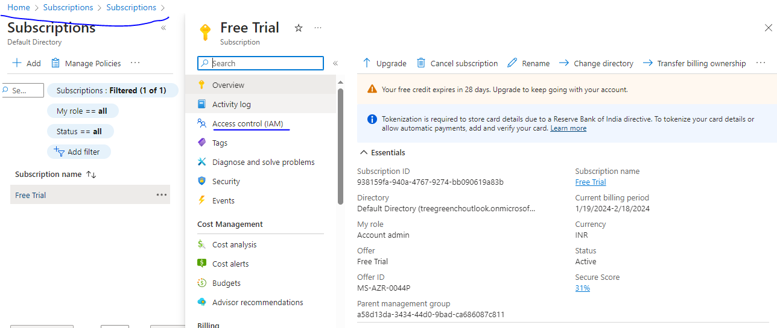

Now click on ADD→ select Add role assignment—select privillage →click on contributor→NEXT

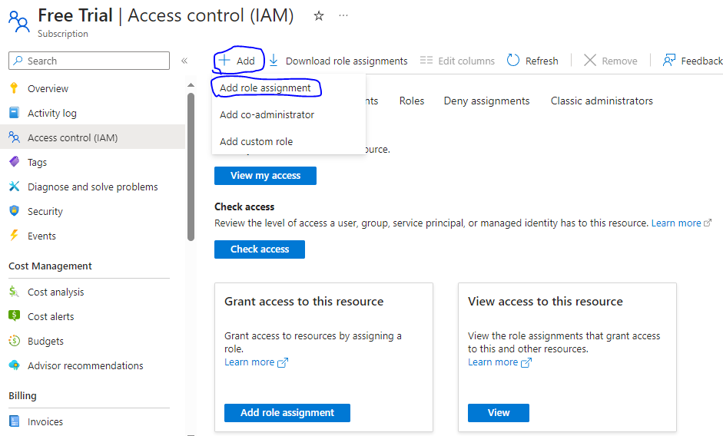

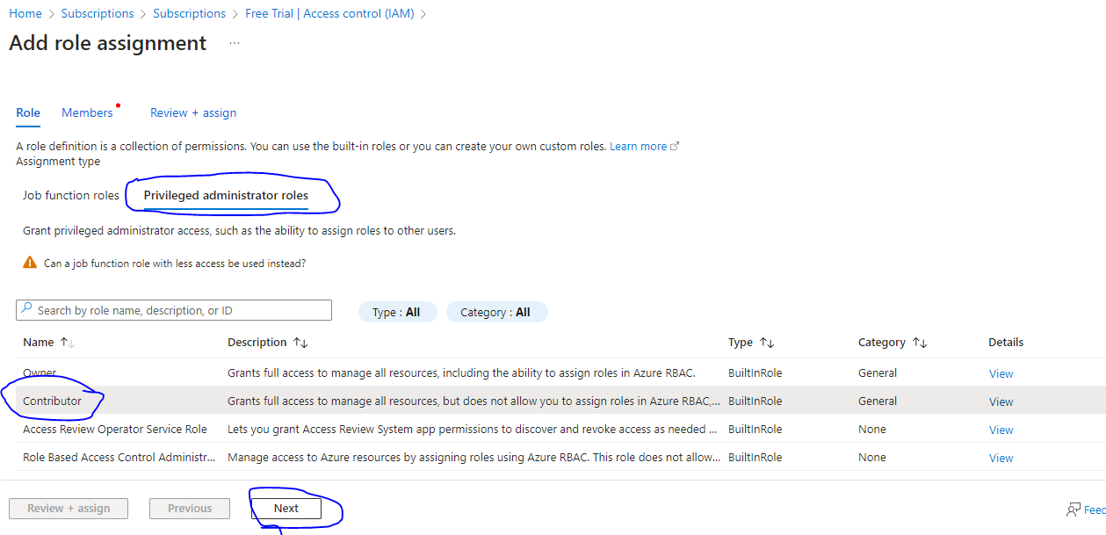

Now →click Members→select members→select here which has we created at secrete certificate description example here I created this one (webappconnection) select –next

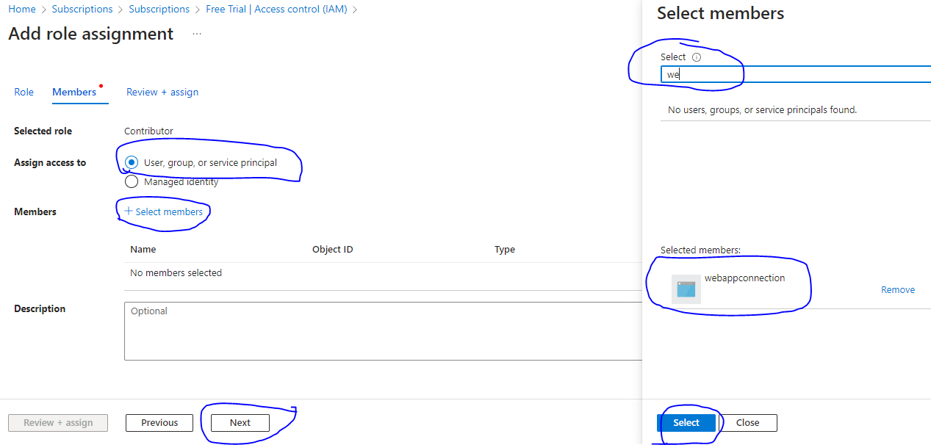

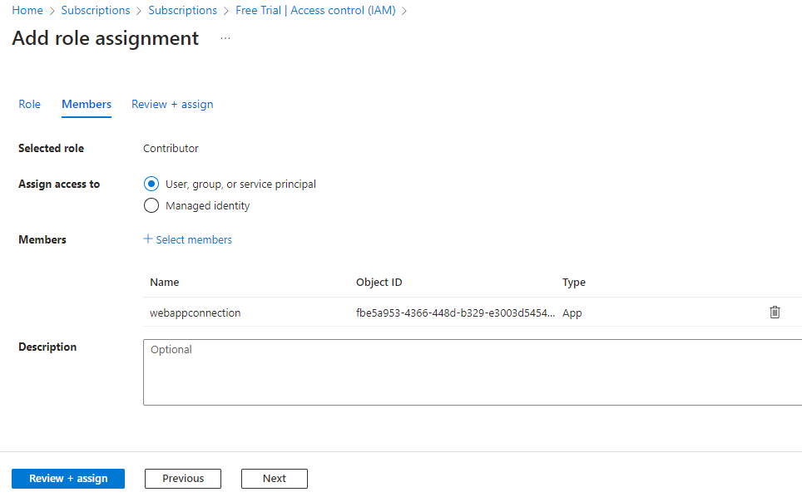

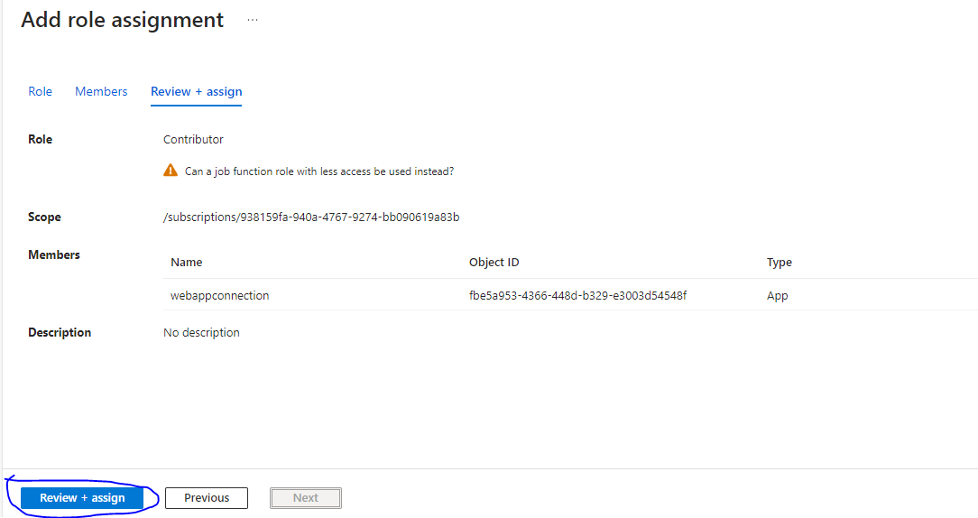

Now go to project settings →service connection →create service connection--

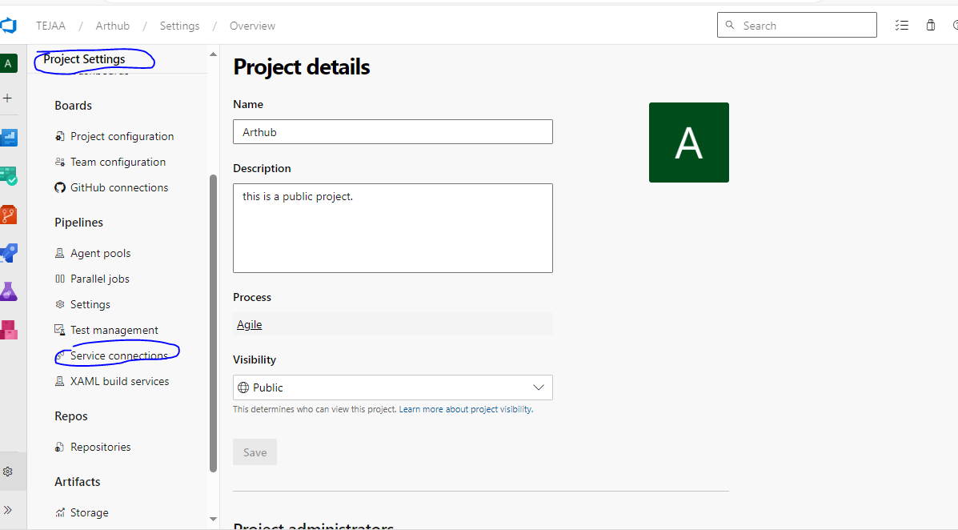

Select Azure resource Manager→next→
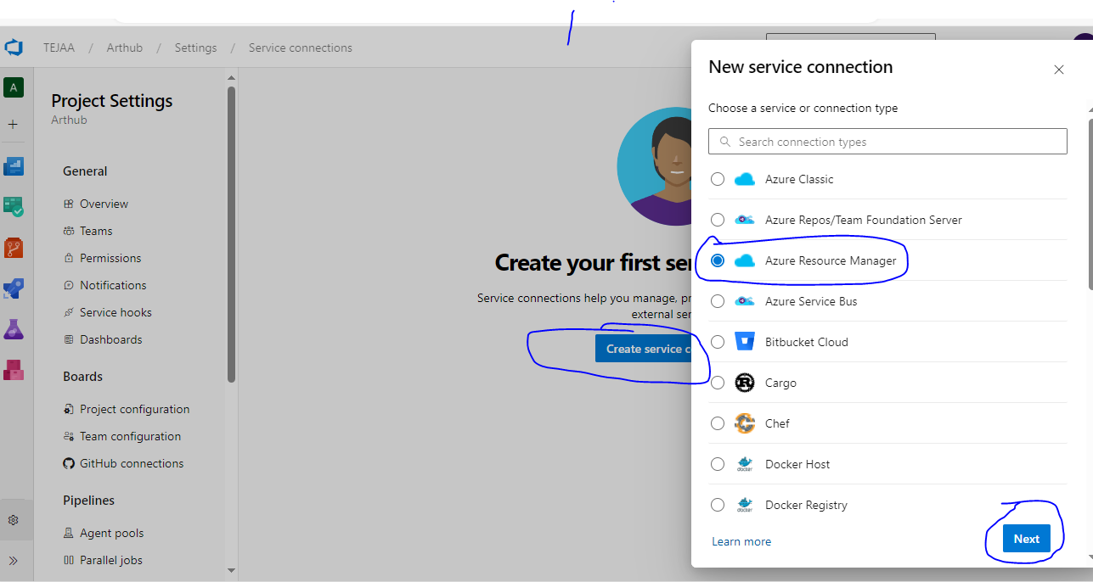

Then Select → Azure Principal(manual)→next
Then below window will open here we need to fill all details:-

Subscription id
Application id (it is available at go to azure AD →app registration→ click web → select created service connection then here foind the application id it is called service principle id)
Serviceprinciplekey:_ is value id (we have created secrets)
Tenant id:-
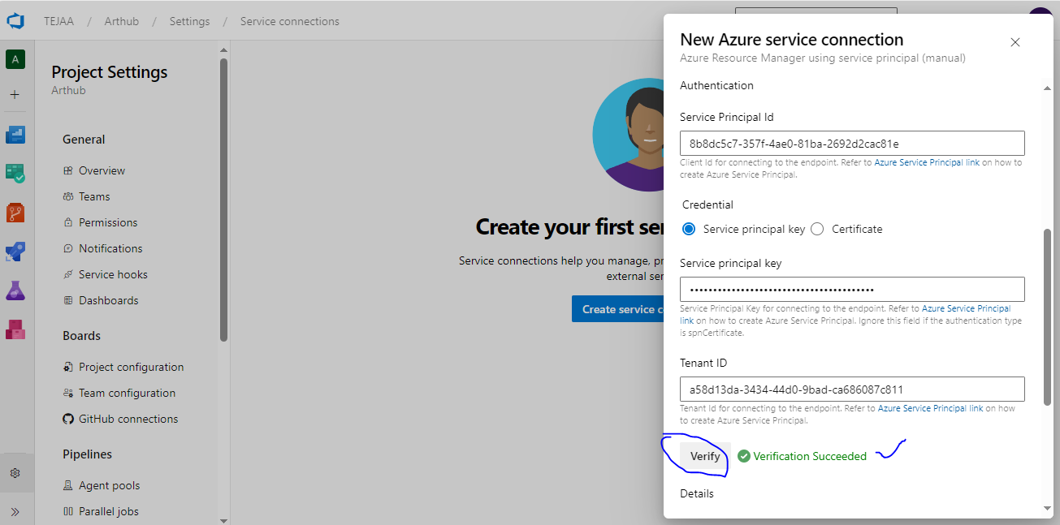

After completed below window showing..

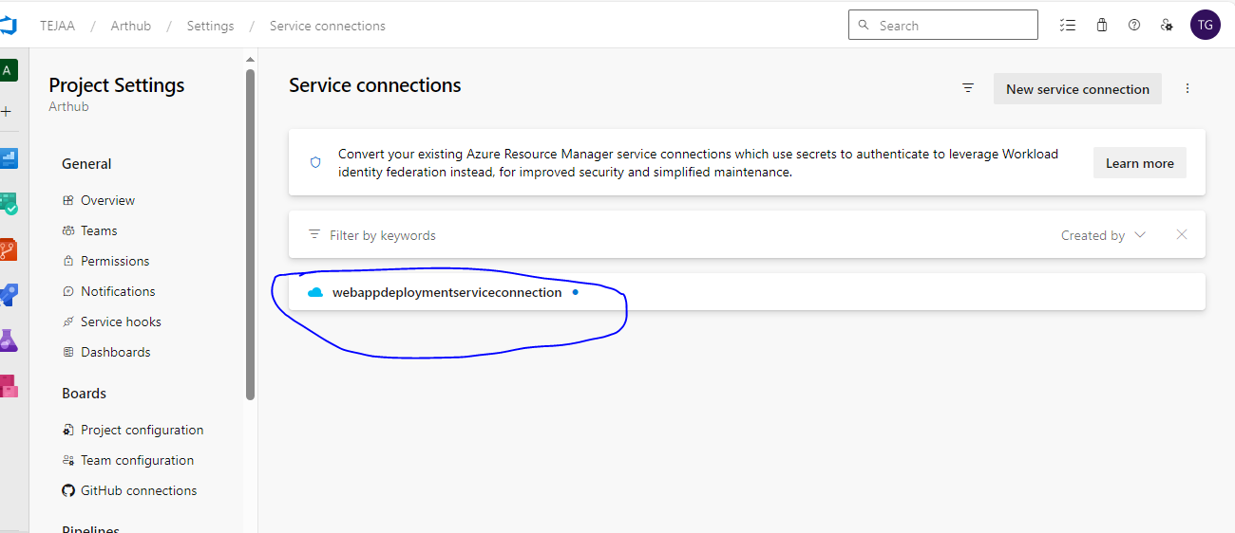

Creating Webapp

Go to webapp service→ drop down create→webapp.
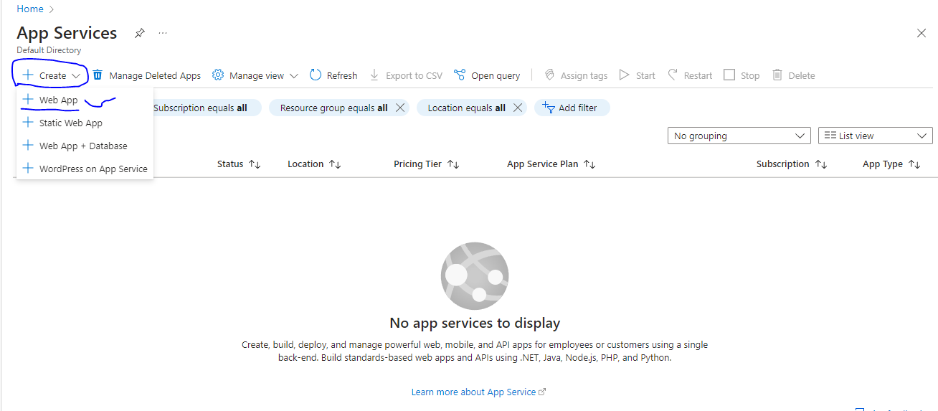

Create webapp and fill the all details and → Review and create.
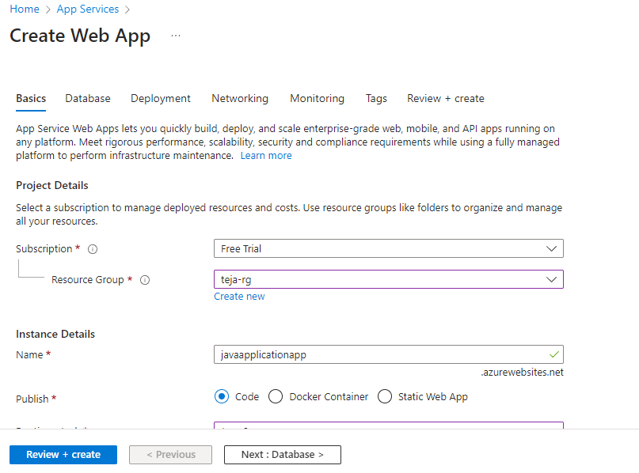

Now we need to run pipeline: - Below is code. This code build the war file and it is store to azure container and down load and deploying in webapp.

trigger:
- main
variables:
- group: "gameoflife" (this is variable secrete for storage account for store the kesy)
pool: mytestpool
stages:
- stage: Build
jobs:
- job:
steps:
- task: Maven@4
inputs:
mavenPomFile: 'pom.xml'
# mavenOptions: '-Xmx3072m'
goals: 'package'
# javaHomeOption: 'JDKVersion'
# jdkVersionOption: '1.8'
jdkArchitectureOption: 'x64'
publishJUnitResults: true
testResultsFiles: '**/TEST-*.xml'

- task: CopyFiles@2
displayName: 'copy files to build artifactory'
inputs:
SourceFolder: '$(system.defaultworkingdirectory)'
Contents: '**/target/*.war'
TargetFolder: '$(build.artifactstagingdirectory)'
- task: PublishBuildArtifacts@1
inputs:
pathToPublish: '$(Build.ArtifactStagingDirectory)'
artifactName: drop
- script: | # this war file copy to azure storage account
az storage blob upload --account-name warfilestore1 --account- key $(key) -f $(build.artifactstagingdirectory)/**/target/*.war --container-name $(cname) -n $(date +%F)-golife-$(Build.BuildId).war

# download the artifact drop from the previous job
# download the artifact drop from the previous job
- task: DownloadPipelineArtifact@2
inputs:
source: 'current'
artifact: 'drop'
path: '$(System.ArtifactsDirectory)'
- task: AzureRmWebAppDeployment@4
inputs:
ConnectionType: 'AzureRM'
azureSubscription: 'webappdeploymentserviceconnection'
appType: 'webAppLinux'
WebAppName: 'javaapplicationapp'
deployToSlotOrASE: true
ResourceGroupName: 'teja-rg'
#SlotName: 'Dev'
packageForLinux: '$(System.DefaultWorkingDirectory)/**/*.war'
#packageForLinux: '$(Pipeline.Workspace)/drop/**/gameoflife-web/target/.war'
appSettings: -CATALINA_OPTS "-Dfoo=bar"
- script: |
# whoami
# cd $(System.ArtifactsDirectory)
# ls
# #sudo mv $(System.ArtifactsDirectory)/**/*.war /opt/tomcat/webapps/gameoflife.war
# pwd
# ls
# cp /home/azureuser/myagent/_work/1/a/gameoflife-web/target/gameoflife.war /opt/tomcat/webapps
# sudo systemctl restart tomcat.service
whoami
$(System.ArtifactsDirectory)
ls
pwd
sudo mv $(System.ArtifactsDirectory)/gameoflife-web/target/*.war /opt/tomcat/webapps/
pwd
ls

Creating variable group for containers:-

Go to project→pipeline under→Library.
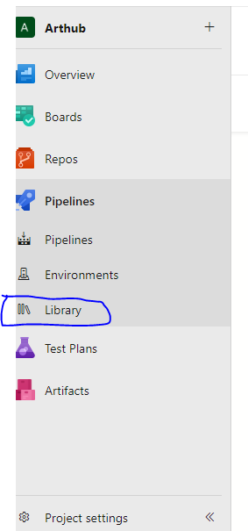

Click on Library→ click on variable group
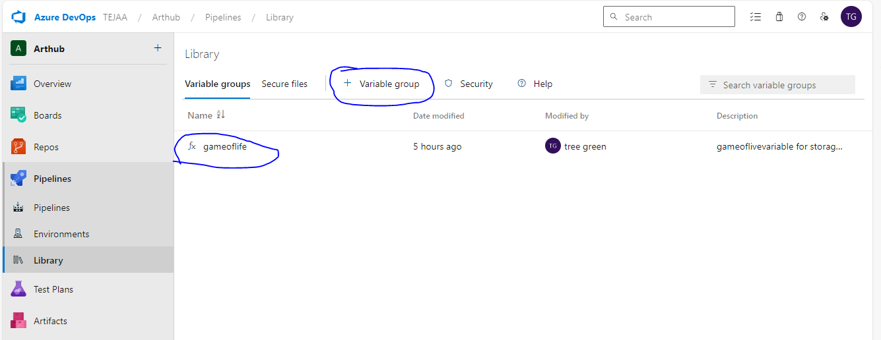

Here create variable group →click add down side→then key= value
Example :- key –(storage account key) values = (storage account secrete value here paste)

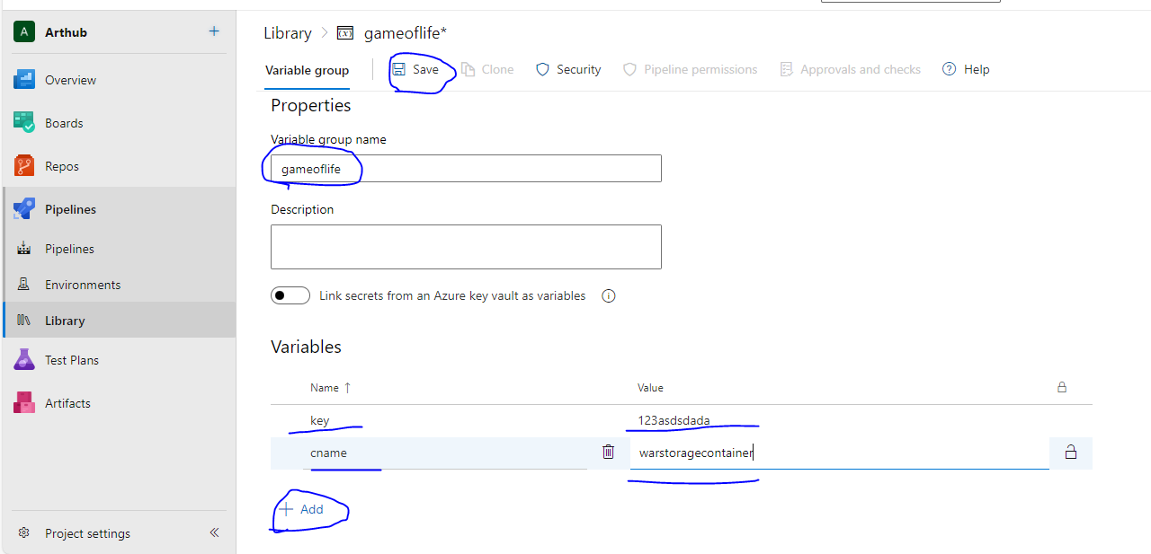
After finish save it .
Then we need to install azure cli in client system.
Creating Selfhost system:-
1.First we create a Ubuntu vm and install for java project install java, maven
2. this vm add to ADO Azure devops for that following below steps:-

Step 1: Install the Azure Pipelines Agent
To begin, we need to install the Azure Pipelines agent on the machine that will act as the self-hosted agent. Here’s how you can do it:
- Open your web browser and log in to your Azure DevOps account.
- Navigate to your Azure DevOps project and click on Project settings in the left side of the page.
- Click on Agent Pools under Pipelines and click on Add pool.
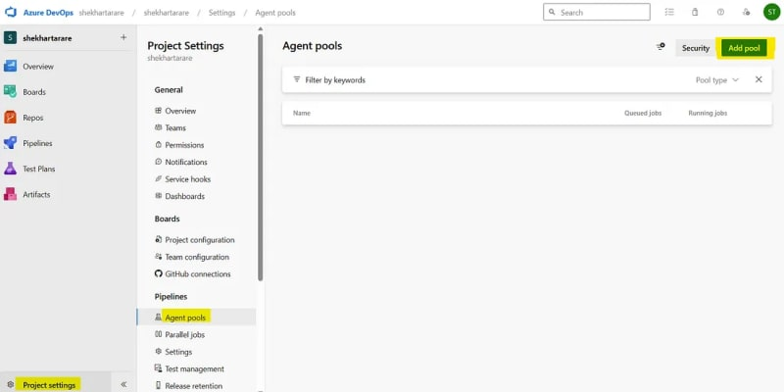
- Select Pool-type as Self-hosted, give it a name and click on Create.
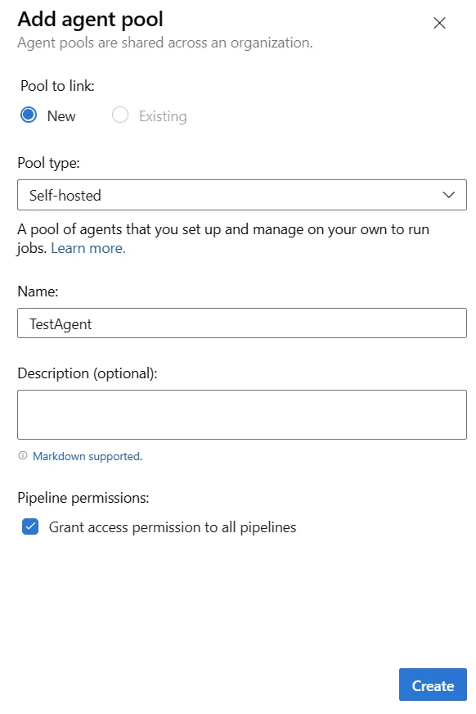
- Click on the created agent.
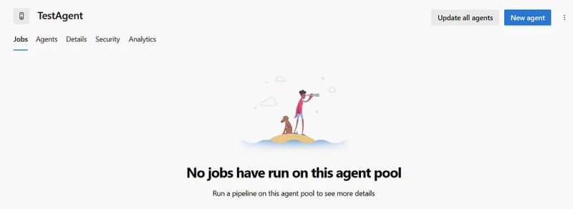
- Click on New agent. It will show the below screen. We just have to follow the steps to create the agent. Click on the Download button to download the agent.
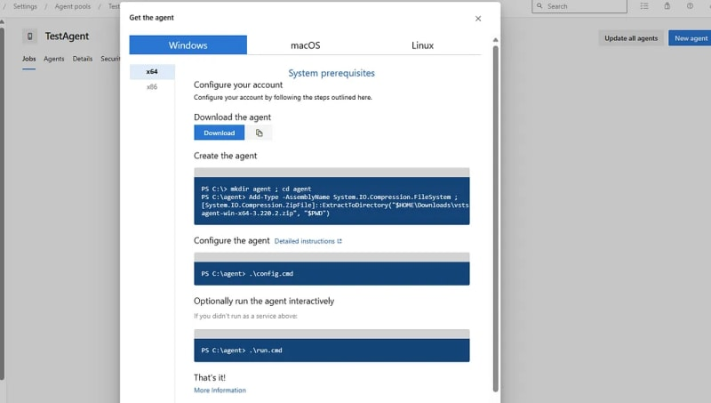

Step 2: Configure the Self-Hosted Agent
Once the agent package is downloaded, we need to configure it to connect with your Azure DevOps account:
- Extract the downloaded agent package to a directory on your machine. I have extracted the files in the below directory.
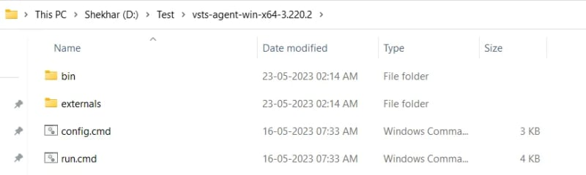
- Open a terminal or command prompt and navigate to the extracted agent directory. Make sure to run the terminal or command prompt as Administrator.
- Run the configuration script by executing the following command:
· On Windows: “config.cmd”
· On Linux or macOS: “./config.sh”
- The configuration script will prompt you for your Azure DevOps account URL and a personal access token (PAT).
· To generate a PAT, go to your Azure DevOps account, click on the small icon on the left side of your profile picture in the top-right corner, and select Personal access tokens from the dropdown menu.
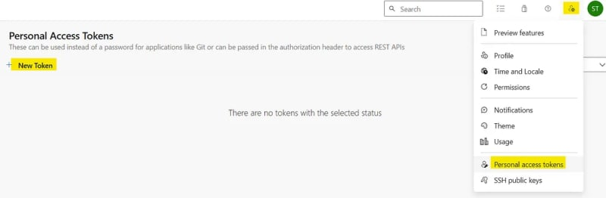
· Generate a new token with appropriate permissions for the agent.
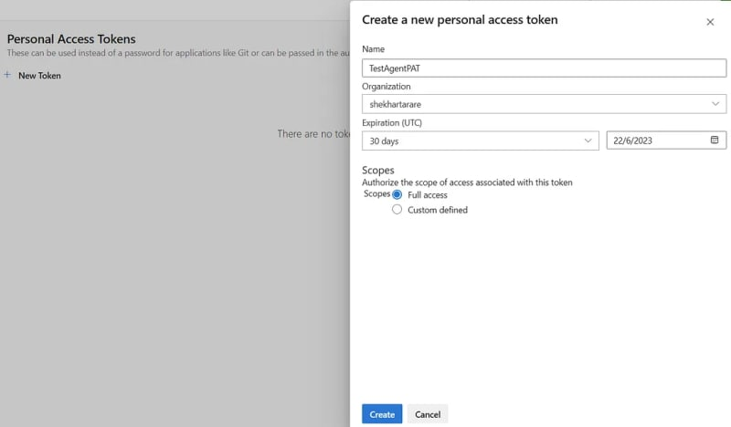
· After clicking the Create button, you will come to other screen where the PAT token will be shown. You just have to copy that. Remember that the token will be shown only once.
- After generating the token above, enter the details on the command prompt..
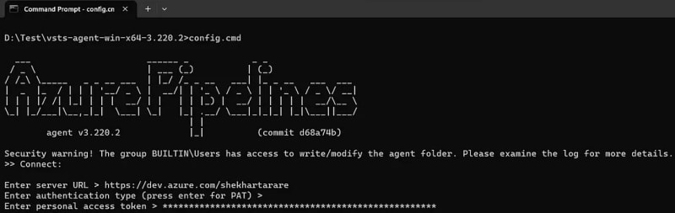
- After entering the PAT, it will ask to enter the name of agent pool. Enter the name of the pool, which we have created above.
- Now, it will ask for agent name and few more details.
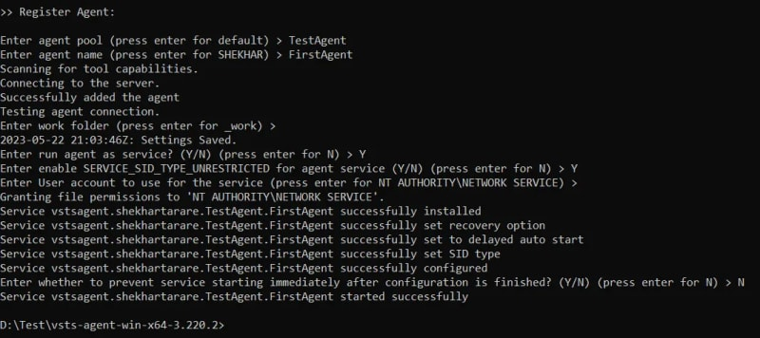
- I have given the permission to run the agent as a service in my machine. I can go to Services and see that.
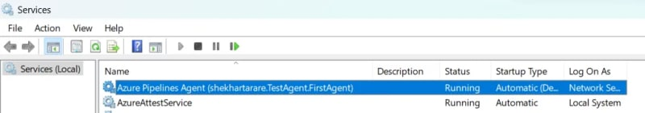
- After completing the configuration, the agent will register itself with the specified agent pool in Azure DevOps. Now, if you go back to your agent, you will see one agent.
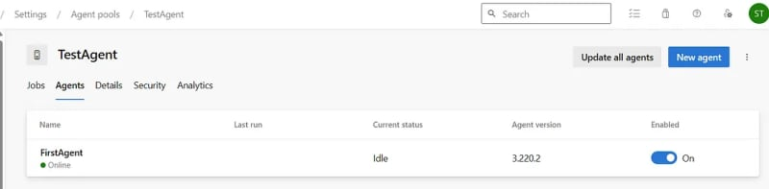

Step 3: Use the Self-Hosted Agent in Pipelines
Now that the self-hosted agent is up and running, you can start leveraging it in your Azure Pipelines:
- Open your Azure DevOps project and navigate to your pipeline.
- Edit your pipeline configuration or create a new one.
- If you click on the stage, and then click on Agent job. In the Agent selection dropdown, you will get your self-hosted agent as an option. Just select that.
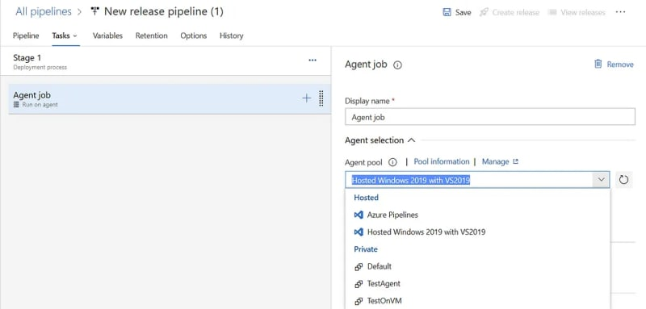
- When you run the pipeline, Azure Pipelines will allocate a job to the self-hosted agent and execute the defined tasks on the configured machine.

For reference click below link:
https://azureops.org/articles/azure-devops-self-hosted-agent/
pipeline with azure account:-

For Deployemnt group add vm
https://learn.microsoft.com/en-us/azure/devops/pipelines/release/deployment-groups/?view=azure-devops

Latest maven installation process:_

https://www.redswitches.com/blog/install-maven-in-ubuntu/
which java
nano ~/.bashrc
Add the following line to the end of the file:
export JAVA_HOME=/usr/lib/jvm/java-17-openjdk-amd64
export PATH=$JAVA_HOME/bin:$PATH (save the file)
source ~/.bashrc run this files
echo $JAVA_HOME
mvn -version

